


University of Queensland School of Economics
QETA Economics Competition 2022

YEAR 11 and Year 10 TEST PAPER

Instructions
- Time: 35 minutes only, in one sitting.
- Supervised conditions
  - No mobile phones.
  - No access to textbooks or to an internet browser.
  - Individual work. No collaboration or assistance from other students or teacher/s.
  - Teachers to actively supervise the test, otherwise prizes may not be able to be awarded.
- Responses
  - Record your name, school name and teacher name in the survey form.
  - Record your answers in the online response form by ticking only one answer per question.
  - If you have entered an incorrect response, press back and tick the correct response.

QUEENSLAND ECONOMICS TEACHERS’ ASSOCIATION INC. gratefully acknowledges the support of the School of Economics, University of Queensland for their continuing sponsorship of the QETA/UQ Student Economics Competition for Queensland Schools.

- Who is considered the “father” of economics?

- John Maynard Keynes
- Thomas Malthus
- Milton Friedman
- Adam Smith

- The Governor of the Reserve Bank of Australia is

- Josh Frydenberg.
- Jerome Powell.
- Jim Chalmers.
- Philip Lowe.

- The “invisible hand” principle in economics refers to

- governments intervening to maximise living standards.
- individuals undertaking decisions for the overall benefit of society.
- producers and consumers making decisions in their own self-interest.
- governments making decisions to harmonise the interests of consumers and producers.

- Economists are concerned that many countries may be heading towards stagflation. This phenomenon occurs when the economy experiences

- rising prices and rising GDP.
- falling employment and rising prices.
- rising GDP and rising unemployment.
- falling unemployment and falling GDP.

- What is the lowest cash rate Australia has had?

- 1.0%
- 0.5%
- 0.10%
- 0.05%

- When was the last time the Australian federal budget was a surplus?

- 2005/6
- 2007/8
- 2012/13
- 2018/19

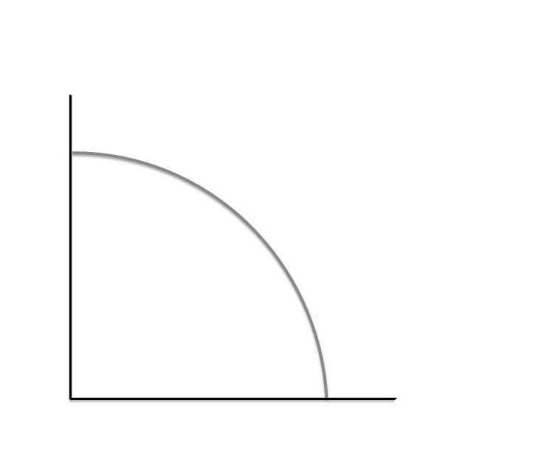
Refer to the above production possibility curve. It illustrates

- the concept of increasing opportunity cost.
- the concept of decreasing opportunity cost.
- that economic resources are underutilised.
- that economic resources are inefficiently utilised.

- According to the 2021 Australian Census, which is the largest generation group?

- Generation Z (10-24 years)
- Millennials (25-39 years)
- Generation X (40-54 years)
- Baby Boomers (55-74 years)

- The Albanese Labor government’s policy to reduce the cost of childcare is aimed at:

- decreasing immigration.
- decreasing the budget deficit.
- increasing the supply of labour.
- increasing the birth rate in Australia.

- The 5.2% increase in minimum wages by the Fair Work Commission (Australia) this year will result in

- an improvement in the distribution of income.
- a greater incentive to employ workers.
- a decrease in federal tax revenue.
- an increase in exports.

- Mr Gamble pays $1 for raffle ticket in which the prize is a day trip to Sydney in business class. The regular price for this trip is $300. However, the organisers of the raffle are offering a cash sum of $200 to the winner as an alternative to the trip itself. If Mr Gamble wins the raffle, what will be the opportunity cost if he decides to go on the trip?

- $1
- $100
- $200
- $300

- In a market economy, changes in the outputs of individual sectors are triggered by changes in the

- size of the population
- distribution of income
- operational decisions of sellers
- prices at which the markets are cleared

- A distinguishing feature of planned economies compared to market economies is that

- managers are the ultimate decision makers of who gets which resources.
- directives, rather than prices, are the mechanism of resource allocation.
- there is greater emphasis upon consumer sovereignty.
- profits in private industries are taxed more heavily.

- Identify the capital good from the following list.

- shares bought by an investor
- washing machine bought by a consumer
- new apartment purchased by a household
- purchase of a new bus by a transport company

- Which of the following is a merit good?

- Any good provided free of charge to consumers by the government
- Any good where private benefits of consumption exceed its social benefits
- Any good that cannot be provided by private enterprise because non – payers cannot be excluded form enjoying its benefits
- Any good that the government believes consumers will buy too little of, if it is provided by the private sector at market prices

- One reason the free market fails to achieve an optimal allocation of scarce resources is because:

- positive externalities lead to an over production of a good.
- positive externalities lead to an over consumption of a good.
- there is underproduction of goods with positive externalities.
- the public sector can provide some goods at a lower price to consumers.

- A significant increase in a country’s imports in likely to

- raise employment of factors of production.
- increase withdrawals from the economy.
- increase injections into the economy.
- raise aggregate demand.

- Households are concerned about inflation. Their response is likely to be to

- increase purchases of imported goods, to steer away from higher domestic prices.
- return to education, to improve their human capital and future income.
- purchase more durable goods, to improve the circular flow of income.
- increase discretionary spending, to avoid higher prices later

- The demand for a product will shift to the right if:

- the price of the product falls.
- a new source for the product is found.
- the prices of substitute products increase.
- an advertising campaign for a substitute product is successful.

- Other things being equal, the reason why the supply curve of a product slopes upwards to the right because:

- producers enjoy higher profits as price rises.
- producers charge more to cover a rise in the price of inputs.
- producers are willing to produce more of the product as its price rises.
- an increase in the demand for the product will bring about an increase in supply.

- The elasticity of supply of a product measures the ease with which:

- its production can be expanded in response to a change in price.
- the production of one product can be increased as that of another is reduced.
- additional units of a factor used in its production can be purchased at market rates.
- units of a variable factor can be substituted for units of a fixed factor used in its production.

Questions 22, 23 and 24 refer to the following table:

Price of chocolate $ (per box) | Quantity demanded (boxes)
10 | 0
9 | 2
8 | 3
7 | 4
6 | 5
5 | 6
4 | 7
3 | 7
2 | 9
1 | 10

- The price elasticity of demand for an increase in price from $8 to $9 is

- 0.375
- 0.625
- 1.00
- 2.66

- Price elasticity is zero when the price

- rises from $4 to $5.
- rises from $3 to $4.
- falls from $7 to $6.
- falls from $10 to $9.

- At which price will the seller maximise revenue?

- $6
- $7
- $8
- $9

- A congestion tax on the use of cars in urban areas during peak travel hours will have minimal impact on road congestion if the demand for

- urban road space is income inelastic.
- urban road space is income elastic.
- urban road space is price inelastic.
- alternative transport is price elastic.

- Three individuals, X, Y and Z, each have 5 units of a durable good for which their demand schedules are shown in the table below.

 | Quantity demanded (units)
Price ($) | X | Y | Z
5 | 0 | 0 | 3
4 | 1 | 0 | 4
3 | 2 | 3 | 5
2 | 3 | 6 | 6
1 | 4 | 9 | 7

In the situation where trade takes place between these individuals at the equilibrium price

- X and Y are buyers, Z is a seller.
- Y and Z are buyers, X is a seller.
- X and Z are buyers, Y is a seller.
- Y is a buyer, X and Z are sellers.

- The ability of profiteers to resell tickets for world cup soccer final matches at a price above the official price indicates that

- the supply curve for tickets is elastic.
- official prices need to be more widely advertised.
- the demand curve for tickets is upward sloping.
- the equilibrium prices are above official prices.

- If the state provides tertiary education free of charge to users, this means that tertiary education

- is available to all.
- involves no opportunity cost.
- Is experiencing market failure.
- cannot be provided by private enterprise.

- Resource allocation refers to the apportionment of

- raw materials.
- factors of production.
- consumers’ income.
- productive capacity.

- The diagram below shows the demand for and supply of rice. If the government fixes a price for rice, the most likely outcome would be.

P_{O}
P_{GOV}
O
Quantity of AUS
Price of AUD in US $
S₀
D₀
Q_{O}

- a shortage of rice of EF.
- excess supply of rice of EF.
- the equilibrium price OP being maintained.
- an increase in price from OP to Pmax.

