


University of Queensland School of Economics
QETA Economics Competition 2023

Year 10 and Year 11 TEST PAPER

Instructions

- Time: 35 minutes only, in one sitting.
- Supervised conditions
  - No mobile phones.
  - No access to textbooks or to an internet browser.
  - Individual work. No collaboration or assistance from other students or teacher/s.
  - Teachers to supervise actively otherwise prizes may not be able to be awarded.
- Responses
  - Record your name, school name and teacher name in the survey form.
  - Record your answers in the online response form by ticking only one answer per question.

QUEENSLAND ECONOMICS TEACHERS’ ASSOCIATION INC. gratefully acknowledges the support of the School of Economics, University of Queensland for their continuing sponsorship of the QETA/UQ Student Economics Competition for Queensland Schools.

- Which country is Australia’s largest trading partner?

- China
- India
- Japan
- America

- In what circumstances is an economy said to be in a recession?

- GDP growth falls in one quarter compared with the previous quarter
- GDP growth falls for two consecutive quarters
- GDP falls for two consecutive quarters
- GDP falls for two consecutive years

- What is a problem the Australian economy is currently facing?

- continued supply chain disruptions
- the level of underemployment
- falling discretionary income
- current account surplus

- The May 2023 unemployment rate in Australia was

- 2.6%.
- 3.6%.
- 4.6 %.
- 5.6%.

- What is Australia’s population in 2023?

- 36 million
- 32 million
- 26 million
- 22 million

- Who is the new Reserve Bank of Australia Governor, starting in September 2023?

- Phillip Lowe.
- Peter Dutton.
- Marion Kohler.
- Michele Bullock.

- With which form of economy is the term “laissez faire” associated with?

- Barter economy
- Primary economy
- Free market economy
- Command economy

- The rate of interest for home loans in Australia is a decision made by

- the lendors.
- the borrowers.
- the Federal treasurer.
- the Reserve Bank of Australia.

- The inflation target in Australia

- is currently 6-7 %.
- aims to anchor price expectations.
- impacts the living standards of households.
- is set monthly by the Reserve Bank of Australia.

- Choose the correct option for June 2023.

 | Australia’s current Finance minister | Queensland’s current Treasurer
A | Jim Chalmers | Katy Gallagher
B | Cameron Dick | Jim Chalmers
C | Jim Chalmers | Anastacia Palaszczuk
D | Katy Gallagher | Cameron Dick

- If the allocation of resources in a fully employed economy becomes more efficient,

- per capita income cannot increase because of inflation.
- producers will gain at the expense of consumers.
- the level of real income per person will increase.
- there will be higher employment.

- Which of the following statements is correct?

- A shortage is caused by too many needs and wants.
- The economic problem is because of finite needs and wants.
- A surplus is caused by excessive supply compared to demand.
- Businesses determine how resources are allocated in a free market economy.

- Refer to the following data of an economy.

Exports | $300m
Imports | $200m
Savings | $100m
Government expenditure | $200m
Investment | $200m
Taxation | $300m
Public debt | $500m

Which of the following statements is correct about this economy?

- Economic activity is decreasing and the budget has an annual surplus.
- Economic activity is increasing and the budget has an annual surplus.
- Economic activity is decreasing and the budget has an annual deficit.
- Economic activity is increasing and the budget has an annual deficit.

- Which one of the production possibility curves below is INCONSISTENT with the statement that “scarce resources have alternative uses”?

Good X
Good Y
Option B
Good X
Good Y
Option A

Good X
Good Y
Option D
Good X
Good Y
Option C

- According to the paradox of thrift, increased savings by individuals will result in

- an increase in national income and greater ability to spend in the future.
- a decrease in national income with future spending unchanged.
- an increase in national income but no overall change in saving.
- a decrease in national income and overall decrease in saving.

- To improve living standards in the country, the treasurer announces that luxury cars will be supplied free.
The government is unlikely to achieve its objective because

- the demand for luxury cars is inelastic.
- there are not sufficient resources available in Australia.
- resources will be diverted from alternative uses to produce cars.
- the more people that have luxury cars, the less desirable they will become.

- A leftward shift of an economy’s production possibility curve will occur when there is

- a decrease in the labour force.
- an increase in the unemployment rate.
- an increase in labour force participation.
- a decrease in the number of available jobs.

- Consumer sovereignty is likely to be reduced where there is

- excessive demand for a good or service.
- a high level of persuasive advertising.
- significant supply of a product.
- a highly competitive market.

- Suppose you have a $50 iTunes gift card with which you can buy (download) songs or videos. Songs cost $1.00 each and videos cost $2.00 each.
What is the opportunity cost of one video?

- $2.00
- $2.00 but increases as more videos are purchased
- constant and equal to half a song
- constant and equal to two songs

- Which of the following will be considered as investment in the circular flow of income model?

- the purchase of a used computer by an auto manufacturer
- purchase of an investment property by households
- government investment in public housing
- developer builds an aged care facility

Refer to the country data provided and answer questions 21 and 22

Year | Consumer price index | Nominal gross domestic product(billion) | Population  (millions)
2015 | 100 | 450 | 10
2022 | 125 | 650 | 12

- The real gross domestic product for 2022 in 2015 prices is

- $450 billion.
- $520 billion.
- $600 billion.
- $620 billion.

- Ceteris paribus, the standard of living in the country

- has improved.
- has decreased.
- has not changed.
- is not able to be determined with the given information.

- An increase in demand for petrol by private motorists is likely to follow an increase in

- the price of second -hand cars.
- insurance premiums for cars.
- road toll charges.
- bus fares.

- A movement along the supply curve for wheat is most likely to have been caused by
- a shortage of skilled farm workers.
- a decrease in the price of fertilisers
- a decrease in personal income tax rates.
- the removal of the excise tax on petrol used by farmers.

- Goods X, Y and Z are normal goods. Good X is purchased as a substitute for Good Y, and as a complement to good Z.
If the price of X remains constant while that of Y falls, and that of Z rises,

- sales of X will increase.
- sales of X will decrease.
- the change in sales of X is not able to be determined with the information provided.
- sales of X remain constant if the percentage increase in the price of Z is the same as the percentage fall in the price of Y.

- The diagram shows the demand and supply curves for fish. Catches vary from day to day but nothing else changes. All fish are sold by auction daily, immediately after they are landed.
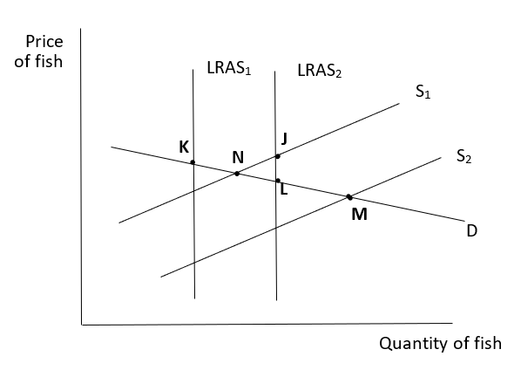

Which two of the points above could represent the prices and quantities of fish sold on consecutive days?

- K and J
- K and M
- J and M
- K and L

- In order to cut down fuel consumption by motor cars, a government introduces a new sales tax on cars over large care. As a result, producers of large cars find that on each car sold their net revenue after tax falls by the amount of the tax.
For these cars price elasticity of

- supply is unity.
- demand is zero.
- supply is unitary.
- demand is infinity.

- The Tragedy of the Commons illustrates why
- common resources are over consumed.
- private goods are under consumed.
- public goods are under produced.
- free goods are over consumed.

- In which one of the following situations will the socially optimal level of pollution be attained?

- The government meets the total cost of eliminating pollution.
- The total benefits and total costs of reducing pollution are equal.
- The marginal benefits and marginal costs of reducing pollution are equal.
- The producer of the good causing the pollution meets the total cost of its removal.

- Which of the following illustrates the concept of external cost?

- Smoking harms the health of the smoker.
- Smoking harms the health of nearby non-smokers.
- Bad weather reduces the size of the wheat crop.
- A reduction in the size of the wheat crop causes income of wheat farmers to fall.

