**Wage reviews pushed wages higher.**

* Wage price index rose 0.9% during the quarter and 4.2% over the year.
* Highest recorded annual growth since the March quarter 2009.
* Public sector wages grew 1.3% due to new workplace agreements, including those for teachers and nurses.

**Inflation continued to impact most goods and services**.

* Consumer price index rose 0.6% in the quarter and was up 4.1% in the year.
* Smallest quarterly rise since March quarter 2021.
* Insurance more expensive, (up 3.8%).
* Tobacco taxes increased the price of cigarettes by 7.0%.

**Businesses continued to invest.**

* Business investment rose a modest 0.7% during the quarter.
* 14th successive quarterly rise.
* Spending on new warehouses and data centres lead to a 5.0% rise in non-dwelling building construction.

**The labour market started to slow.**

* Job vacancies fell slightly by 0.7% during the quarter but remained high.
* Unemployment rate inched up reaching 3.9% in the month of December.
* Participation rates stayed close to record highs.

**Reference:** Australian Bureau of Statistics, 6 March, 2024**,** *11 things that happened in the Australian economy during the December quarter*,<https://www.abs.gov.au/articles/11-things-happened-australian-economy-during-december-quarter>

**11 things that happened to the Australian economy during the December quarter 2023.**

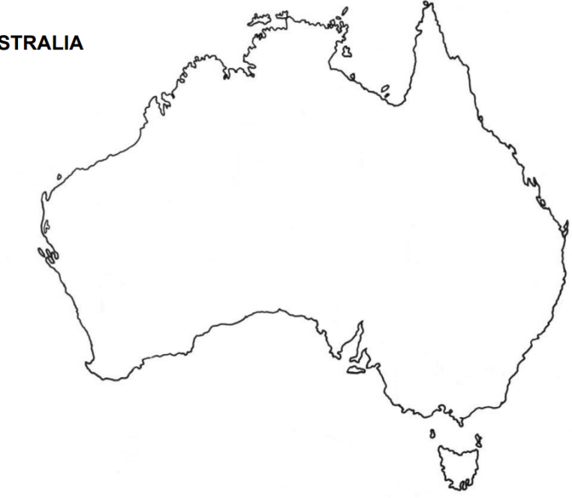

**Travellers had wanderlust for cheaper holidays.**

* As many Australians headed home from their European summer holidays, spending on overseas travel fell 9.0%. This reflected a shift towards destinations closer to home, led by New Zealand and Indonesia.
* Spending by visitors to Australia rose 1.2% and is now above pre-pandemic levels.

**Labour productivity rose again.**

* Australians worked similar hours to last quarter, with the amount of time spent at work remaining historically high.
* Overall labour productivity rose 0.5% during the quarter, which was the second successive quarterly rise following a period of falling labour productivity.

**Government spending outpaced household spending.**

* Commonwealth government spending (excluding Defence) added 0.2 percentage points to economic growth.
* Growth was driven by government benefits for households and employee expenses, e.g. increased Medicare expenditure, pharmaceutical benefits and expenditure linked to the Voice to Parliament referendum.

**Inventories reduced as imports fell.**

* Imports of consumption goods such as food, clothing, electrical items and cars fell 5.4% during the quarter.
* As imports of these goods fell, many businesses reduced their existing stock to meet consumer demand.

**We ate at home more.**

* Household consumption rose marginally by 0.1%, following a fall of 0.2% last quarter.
* Spending on food rose 0.9%, while spending on catering services, pubs and clubs decreased.
* Total discretionary spending by households fell 1.6% over the year.

**Households saved slightly more.**

* Households saved 3.2% of their income this quarter.
* Government social assistance benefits grew 5.9%.
* Interest paid on mortgages rose by 5.0%, as some borrowers continued to come off lower fixed-rate loans.

**Our economy grew**.

* 0.2% higher in the Dec quarter 2023 and 1.5% in annual terms.
* 9th successive quarter of growth.
* Slowest annual growth rate since the COVID-19 pandemic.
* Strong population growth saw GDP per capita fall 1.0% over the year.