**Empowering Educators, Elevating Economics**

**QETA Economics Conference 2024**

**Friday**

**16 August 2024**

8.30am to 2.30pm

8am registration

We are proud to present another full day of Professional Development to enrich your Economics teaching.

* Face to face – University of Queensland
* Online, for our regional and remote members
* QETA scholarships available to cover flight costs for regional and remote teachers – refer website for application details.

**Teachers will have an opportunity to:**

* upskill and update their knowledge of teaching, learning and assessment
* participate actively by asking questions – coordinated online experience
* increase communities of practice

**Members   
$125+GST** (before 19 July) or $150+GST after 19 July

**Non-Members $200+GST** (before 19 July) or $225 after 19 July

**Preservice teachers $25+GST** (become a member now! Non-member pre-service $75)

**Keynote speaker:  
Diana Mousina**

Deputy Chief Economist   
AMP

Background: Economist and Executive Committee member of the Australian Business Economists (ABE)

*Committed to developing and communicating views on the Australian and Global economy.*

**Guest speaker: Tanya Hornick**

Strategic Partnership Manager, Australian Bureau of Statistics (ABS)

Background: Data and digital professional, statistician.

*Committed to advancing and uplifting the capability and pride in public administration and public purpose work.*

*A PD Day designed to provide content-rich and hands-on learning experiences for Economics teachers supporting AITSL standards 2.1, 2.2, 2.3, 3.2, 3.3, 4.2, 6.2, 6.3, 6.4, 7.4.*

**PROGRAMME**

**Sponsored by **

|  |  |  |  |
| --- | --- | --- | --- |
| **Time** | **Event** | **Speaker** | **Attendees** |
| 8:00am – 8.30am | Arrivals and register | | All |
| 8:30am – 9.30am | St Hilda’s School | Majda Benzanati  Transforming Economics Education | All |
| 9.30am –10:15am | Guest | Tanya Hornick, Australian Bureau of Statistics  (30 mins + 15 mins questions) | All |
| 10:15am-10.45am | Morning Tea |  |  |
| 10.45am-11.30 am | Keynote Speaker | Diana Mousina, AMP  (30 mins + 15 mins questions) | All |
| 11.30am – 12.15pm | QCAA | 2025 Syllabus + update on subject report | All |
| 12.15-12.30pm | Sponsor | Sponsorship presentation ATOMI |  |
| 12.30– 1.00pm | Lunch |  | All |
| 1:00pm -1.45pm | Master Class 1 | Write like an Economist  James Williamson | Attendees’ choice |
| Master Class 2 | AI in the Economics Classroom Julie-Anne Angell and Hein Kamffer | Attendees’ choice |
| Masterclass 3 | Maximising exam performance  Justin Virly | Attendees’ choice |
| 1.45pm – 2:30pm | Master Class 1 | Write like an Economist  James Williamson | Attendees’ choice |
| Master Class 2 | AI in the Economics Classroom Julie-Anne Angell and Hein Kamffer | Attendees’ choice |
| Masterclass 3 | Maximising exam performance  Justin Virly | Attendees’ choice |

**Register now! Face to Face** or **online**

Regional and remote teachers will receive an online link

prior the event. Contact [info@qeta.com.au](mailto:info@qeta.com.au) for details.

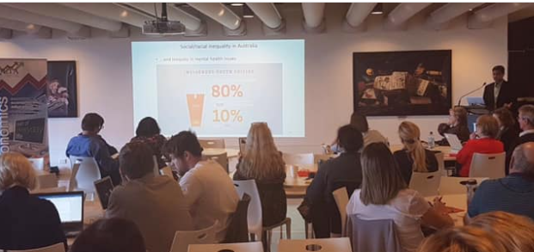

**Presenters**

**Diana Mousina**

Diana is the Deputy Chief Economist at AMP.

Diana joined AMP in 2016 within the AMP Investments team. Diana’s responsibilities include providing global economic and macro investment analysis to retail, institutional and internal customers through her regular “Econosights” reports and presentations. Diana regularly presents AMP’s macro views across various media outlets including ABC, SBS, Bloomberg, CNBC, AusBiz and mainstream Australian television networks and radio stations. Diana also contributes to the asset allocation decisions of the AMP multi-asset funds.

Previously, Diana worked at the Commonwealth Bank of Australia as an economist in the Institutional Banking & Markets division. Diana holds a Bachelor of Commerce/Economics and has a Master of Finance (in funds management), both from the University of New South Wales.

**Tanya Hornick**

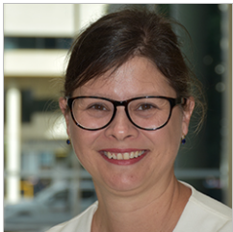

Tanya is the Strategic Partnerships Manager at the Australian Bureau of Statistics (ABS).

Tanya is a data and digital professional and is currently working on supporting the ABS strategic relationship with the Queensland government, focused on collaboration, partnerships of mutual-benefit, and federal to state relations. Prior to taking up this role, Tanya has had extensive experience in working across the ABS business, including population, social and economic statistics.   She has a particular passion for growing the cadre and capabilities of young and emerging public service leaders, acknowledging their important roles and contributions now and into the future.

Tanya is a member of the Committee for Economic Development Australia (CEDA) Queensland State Advisory Committee and Vice-President and Secretary of the Institute of Public Administration Australia Queensland.

**Majda Benzenati**

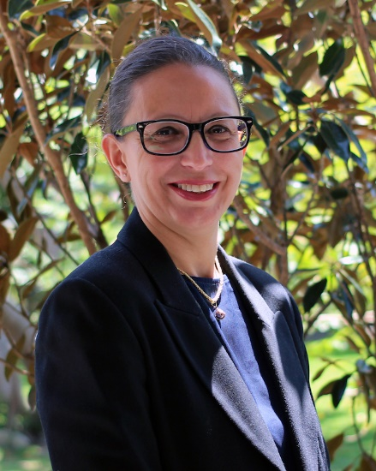**Transforming Economics Education: Fostering Trust, Meaning, and Critical Thinking for Modern Learners**

As a National Lead Teacher, Majda’s dedication centres on advancing teaching and learning practices while actively collaborating with fellow educators. Recognised with an Excellence in Educational Leadership Award in 2024 by the Australian Council for Educational Leaders (Queensland), Majda holds National Lead Teacher certifications from both Independent Schools Queensland (ISQ) and the Australian Institute for Teaching and School Leadership (AITSL). Majda also leads the Community of Practice – Economics (CoPE) on the Gold Coast, where she actively fosters professional growth and development among teachers through collaborative efforts and the sharing of best practices.

**QETA Conference Scholarship**

**for**

**Regional Queensland Economics Teachers**

**Empowering Educators, Elevating Economics**

**QETA Economics Conference 2024**

QETA values the contribution of all members across Queensland and is especially keen to develop strong teacher networks in regional Queensland. The aim is to support you in your teaching of Years 7-10 Economics and Business, and Year 11 and 12 Economics.

Applications are invited from Economics teachers in regional Queensland (not including Brisbane, Gold Coast, Sunshine Coast and Darling Downs) to attend the **QETA Annual Conference on Friday 16th August 2024, being held in Brisbane**.

**The scholarship will cover flight costs to attend the QETA Conference**. To maximise how many regional teachers can participate in the scholarship, we are hoping you can arrange accommodation with family or friends.

To apply, please reply to [info@qeta.com.au](mailto:info@qeta.com.au) outlining how attending the QETA Conference will benefit your Economic classroom practices and your regional network / community of practice. (One short paragraph, “Conference 2024 scholarship’ in the subject line). Decisions will be made regarding applications on Friday, 2nd August 2024.

We look forward to meeting Economic teachers from across the state!